DLAP ACH Deployment Guide

Change History

| Version # | Date | Modified By | Description |
| --- | --- | --- | --- |
| 2.0.0.0 | 03/08/2018 | Ashok Pudota | Initial DLAP ACH Deployment |
| 2.0.0.1 | 03/22/2018 | Ashok Pudota | Updated Deployment Version from 2.0.0.0 to 2.0.0.1.  Updated ACH Request Schema.  Updated WSDL |
| 2.0.0.2 | 05/18/2018 | Ashok Pudota | Updated Deployment Version from 2.0.0.1 to 2.0.0.2.  DCMM-3724: Updated ACH mapping |
| 2.0.4.0 | 06/11/2018 | Ashok Pudota | Updated Deployment Version from 2.0.0.2 to 2.0.4.0  Fixed following Issue.  DCMM-3607  . |
| 2.0.9.3 | 10/05/2018 | Ashok Pudota | Updated Deployment Version from 2.0.0.4 to 2.0.9.4  Fixed following Issue.  DCMM-5618 |

**Contents**

1. **Special Notes……………………………………………………………………………………………………………………….2** 
   1. **Username and Password instructions……………………………….…………………………………….2**
2. **Initial Deployment instructions ……………………………………………………………………………………………3**
3. **Re-Deployment** **instructions………………………………………………………………………………………………….6**

Special Notes:( DLAP Username and Password update instructions)

|  |  |  |
| --- | --- | --- |
| **Environment** | **DALP Update** | **Location** |
| DEV-INT | **UserName:** Dlap  **Password:** Basic2017 | Create a **local User** on server machine with username and password. |
| QA | **UserName:** Dlap  **Password:** Basic2017 | Create a **local User** on server machine with username and password. |
| PROD | Credentials: **N/A**  **check with Steven** | Create a **local User** on server machine with username and password. |

Username and Password update instructions:

1. Open **Local Users and Groups** on System Tools and Create **Username** and **Password**. for Dlap Service.

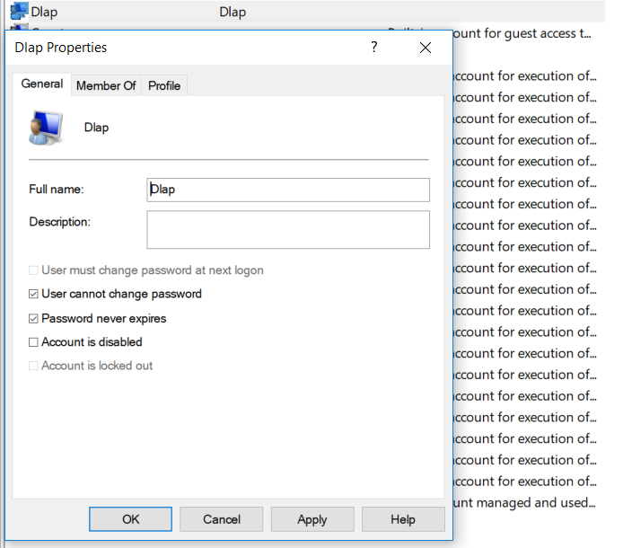

Initial Deployment Summary:

**Msi Installation:**

1. Open BizTalk Administration console and Import/Install the **DLAPACH.msi** into the **Small Business Administration** application then complete the wizard by clicking Finish button and check mark the option Run Application Installation Wizard again to Install the MSI.
2. Next, import the **DLAP ACH Binding Info.xml** binding file after updating **Salesforce** send port configuration into the **Small Business Administration application.**
3. Start all the BizTalk artifacts related to **DLAP ACH as shown in the below screenshot**.

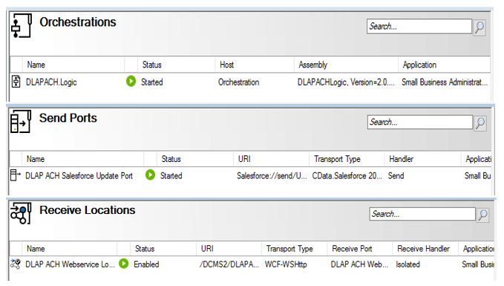

1. **Restart** All the **Host-instances.**
2. Open **IIS** (Internet Information System) right click on **DLAP ACH** Website and validate appropriate **Application Pool** (i.e. **DLAP ACH**) is selected.
3. Next, select **DLAP ACH** Website and go-to Authentication page on IIs and make sure **Basic Authentication** is **enabled** and remaining all are disabled as shown in the below screen-shot.

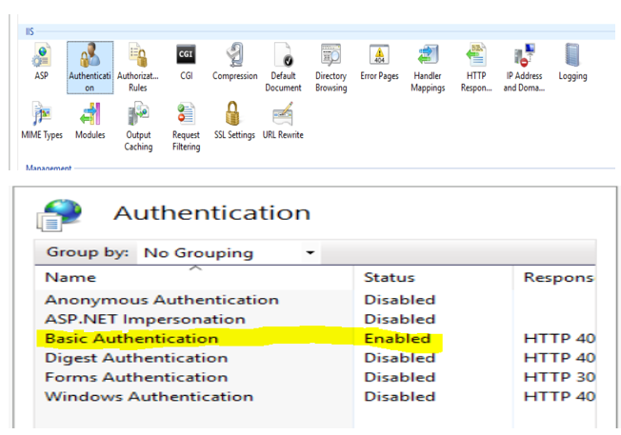

1. Next, Select **Authorization Rules** page on IIs and make sure only **Dlap User** is allowed as shown in the below screen-shot.

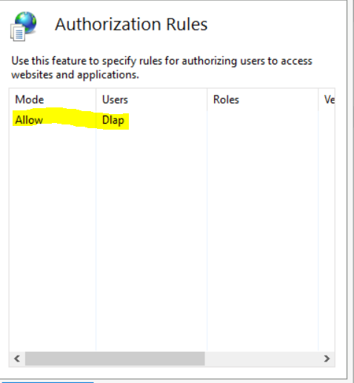

1. Reset/Re-start **IIS** (Internet Information System).
2. Browse the following **DLAP ACH** (HTTPS://) Website and make sure the site is up-running.

**Validate Application Being Deployed:**

1. Go to **BizTalk Administrator Console**, make sure **all** BizTalk artifacts related to **DLAP ACH Interface** are up-running.
2. Open **DLAP ACH Receive Location** and validate security properties as shown below.

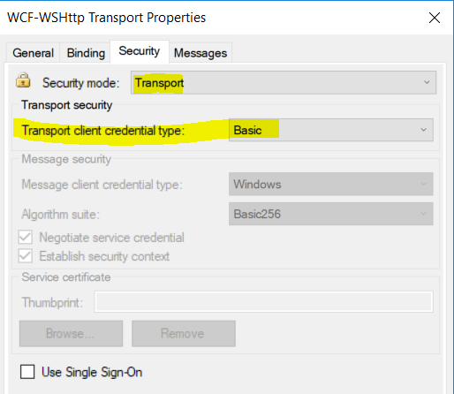

1. Go to **IIS**, make sure IIS is started.
2. Browse the **DLAP ACH** web site (HTTPS://) and make sure the site is up-running.
3. Open Soap-UI project attached on Deployment folder and post the sample message.

Re-Deployment instructions:

**Msi Installation:**

1. Go to BizTalk Administration console **stop and Unenlist all** the BizTalk artifacts related to **DLAP ACH Interface:**

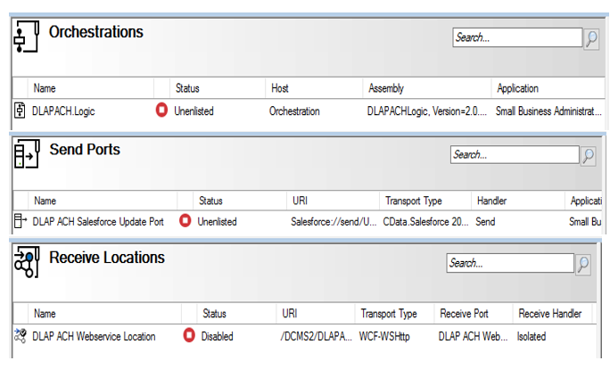

1. Remove Old Assemblies 2.0.0.4 and WEB Directory as show in the below screen-shot.

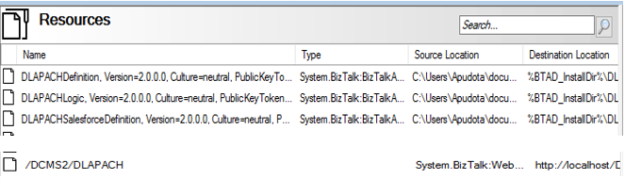

1. Next, Open **BizTalk Administration console** and **Import/Install** the **DLAP ACH 2.0.0.1.msi** into the **Small Business Administration** application then complete the wizard by clicking **Finish** button and check mark the option **Run Application Installation Wizard** again to Install the MSI.
2. Next, import the **DLAP ACH Binding Info2.0.0.1.xml** binding file after updating **Salesforce** send port configuration into the **Small Business Administration application.**
3. **Start** all the **BizTalk artifacts (i.e. Receive location, Send ports and Orchestration)** related to **DLAP ACH** Interface.
4. **Restart** All the **Host-instances**.
5. Open **IIS** (Internet Information System) right click on **DLAP ACH** Website and validate appropriate **Application Pool** (i.e. **DLAP ACH**) is selected.
6. **Reset/Re-start IIS** (Internet Information System).
7. Browse the following **DLAP ACH** (HTTPS://) Website and make sure the site is up-running:

**Validate Application Being Deployed:**

1. Go to BizTalk Administrator Console, make sure **all** BizTalk artifacts related to **DLAP ACH** Interface are up-running.
2. Go to IIS, make sure IIS is started.
3. Browse the DLAP ACH web site (HTTPS://) and make sure the site is up-running.
4. Open Soap-UI project attached on solutionItems folder and post the sample message.